## Meeting Topics

1. ***Hazard mitigation plan update –*** *Julie*

Contacted each transmission operator in VA and one LDC. Background information on how hazard mitigation plans help tell the story/provide the reason for state & local governments to consider implementing land use planning practices and other measures to enhance pipeline safety using their authority. The hazard mitigation planning leverages an existing process to build a sustainable, ongoing channel to engage governments in pipeline safety discussions. Two conference calls have been held. Topics have included discussion about data in NPMS and data VDEM uses/produces for the HM process, a draft “Valuation of Pipeline Incident Impacts” spreadsheet, discussion about the potential impact of a Karst on pipelines in VA, and the impact of VA being a Dillon’s Rule state on implementation of PIPA RPs.

The HM group is meeting in person at VDEM (Richmond, VA) on May 15th.

Draft agenda:

1. Background…how/why did this pilot get started?
2. Operator overview of their system and their integrity management program
3. VDEM overview of VA hazard mitigation process/GIS/plans for natural hazards and what type of mitigation strategies have resulted from it, intergovernmental coordination role, what persuaded VDEM to enhance their plans for pipelines
4. What benefits everyone hopes to gain from this effort?
5. Pipeline Failure Causes document (to be distributed soon)
6. Risk/Vulnerability Assessment - Valuation of Pipeline Incident Impacts

Participants:

* George Roarty, Directory, Recovery & Mitigation, Virginia Department of Environmental Management (VDEM)
* Matt Wall, Hazard Mitigation Program Manager, VDEM
* Robbie Coates, Hazard Mitigation Coordinator, VDEM
* Jim Hotinger, Assistant Director VSCC
* David Cicoria, Manager, Systems Operations, Columbia Gas of Virginia, Nisource (Gas Transmission and Distribution)
* Buzz Fant (Director, Compliance Codes and Standards), James Nickels (Manager, Risk Engineering), and Darrell Donoho (GIS Systems), Kinder Morgan Pipeline (Liquid Transmission)
* Scott Bergman, DOT compliance representatives , NuStar (Liquid Transmission)
* Quintin Frazier, Manager-Compliance Codes and Standards, Plantation Pipeline, Kinder Morgan (Liquid Transmission)
* Timothy Gross, District Manager, Colonial Pipeline (Liquid Transmission)
* Greg Ford, Director, Operations & Project Services ,Williams (Gas Transmission)
* Blase Grasso, Manager Project Engineering, NuStar (Liquid Transmission)
* Aaron Martinez, DOT compliance representatives, NuStar (Liquid Transmission)
* Chaz Lehman, Area Manager, NuStar (Liquid Transmission)
* Ken Seals, Terminal Manager, NuStar (Liquid Transmission)
* Amy Nelson – GIS Manager, PHMSA
* Dwayne Teschendorf, Senior Technical Advisor, Spectra (Gas Transmission)
* Stephen Doyle, DOT compliance representatives , NuStar (Liquid Transmission)
* Nustar Terminals – Blase Grasso
* Herb Wilhite, CYCLA
* Julie Halliday, Sr. Program Manager, PHMSA

VDEM partners with VA Tech to model hazards in the GIS. They have imported the pipelines from NPMS into the GIS.

1. ***PIPA & Dillon’s Rule State*** **– guest speaker Matt Wall, VDEM** - Hazard Mitigation Program Manager, Virginia Department of Emergency Management

Simplified, home rule says community can do anything it wants unless state says it can’t. Dillon’s rule says community can only do what state says it can do. E.g., under Dillon’s, community cannot set ordinance for more restrictive building codes than state has set. *Rebecca Craven –* sounds like that would apply to new pipelines but perhaps not to basis of PIPA recommendations. *Matt* – missing link is master or comprehensive development plan as that is where design guidelines, zoning ordinances, setbacks, etc. are developed. *Rebecca* – Would this necessitate all communities have the same building permitting process? *Matt* – All communities have code officials trained by same agency. Requirements for obtaining a building permit would be very similar or same throughout each community. Each land planning agency has a code official. The code officials are all trained by VA Department of Housing and Community Development for consistency. For example, the EIS is the same throughout the state. The requirement to call 811 is an example of a land development outreach required at the state level. *Question* – would this extend to recommendations such as BL05 where it is simply recommended that communication occurs between builder and operator? *Matt* – likely not. Consultation would likely not impose an economic constraint on the builder/developer. Communication and education as mitigative actions should be OK, in fact encouraged for adoption by any and all communities.

*Matt* - For communities to be able to understand the value, they should be able to look at an evaluation scale/matrix of the postulated actual impacts. *Question* – how would evaluation matrix be used? *Matt* - It can be used to measure relative risk in existing locations/situations. This could be used to help guide development decisions within a community for future development and for future pipeline locations. *Andrew Kohout* – The PIPA report tries to address both communications and ‘hard’ items that can be done (e.g., building orientation, land use, etc.).

*Matt –* VDEM mirrors FEMA relative to looking at common types of hazardous events that could occur at a location and the types of consequences that could result, and the mitigative actions that would give the most “bang for the buck”. E.g., flood events and the consequences to individual residences could be mitigated by requiring that the first floor elevations of the houses be raised above a certain level. *Andrew Kohout* – PIPA report looks at both avoiding incidents and at mitigating the impacts of an incident. *Matt* – Need to also keep in mind that ideally the mitigative action would have both direct and indirect benefits. VDEM would like to be able to integrate results of this effort into the state HMP to increase the benefit of recommending to all communities state-wide.

*Matt –* in some cases, there may need to be more concrete requirements on the developer than just the consultation. E.g., don’t lock in a cul-de-sac on the back side of a pipeline without alternative egress in the case of an incident. *Recommendation* – Provide Matt existing PIPA info. **ACTION**: Julie. Will send link to trifold brochure to Matt. He has a copy of PIPA RPs..and much more. We will work our way back to the PIPA recommended practices after the risk assessment phase…I tried giving him the pancake mix first but he needed to have the story developed first. Susan will send Matt a copy of Spectra’s Developer’s Handbook.

Rebecca asked what is the link between hazard mitigation plans and getting the PIPA RPs into the hands of local planners. Here are the steps:

* 1. Identify hazard (we provide awareness/education/information about pipelines)
  2. Vulnerability assessment (we provide information about pipeline failures and incidents, cause of failures, operators’ mitigation measures – regulatory required and voluntary, incident case studies, consequences of pipeline incidents)
  3. Capability assessment (the hazard mitigation manager/team review mitigation measures currently implemented and potential mitigation measures state/local governments can take  – this is Matt’s “pancake” mix which we are providing  – PIPA RPs, Pipeline Emergencies training, 811/other excavation damage prevention measures on PHMSA Stakeholder Communication website, pipeline public awareness material). What does this look like for other hazards? How does a capability assessment relate to land use planning? Land use planning tools are a mitigation strategies for many hazards – think flood zones. Please see local government plan [Catawba County HM plan](http://www.catawbacountync.gov/EmergencyServices/Hazard/Section7.pdf) – the first screen shot below.
  4. Migitation strategy (See pages 5-6 thru 5-17 of [VDEM’s Mitigation Strategy](http://www.vaemergency.com/sites/default/files/2010-RedactedVersion.pdf) document – 2nd screenshot below. This is the plan delineating specific mitigation measures a government will implement. Note that the measures will be led by various agencies but VDEM is the group that performs the intergovernmental coordination/plan oversite. Several shown here are for mapping (BL01 map pipelines could be on the list – map pipelines in comprehensive plan, state DOT GIS, public works GIS, etc.).

The huge benefit of leveraging the hazard mitigation process is that the mitigation manager knows all the agencies who would have a role in implementing the strategy (I never would have known to that the VA Department of Housing and Community Development trains all code officials ensuring consistent zoning practices across the state), they have an existing relationship with the agency, they provide credibility to the mitigation strategy, they know the state/local laws – Dillon’s Rule vs. Home Rule, and the process is performed by most every state/local government every five years. The level of acceptable risk is decided on by the state/local government, the hazard mitigation process involves pipeline operators, effected state/local agencies, and the public. Pipelines may not be of interest to them during this update but the information will be considered again in 5 years.

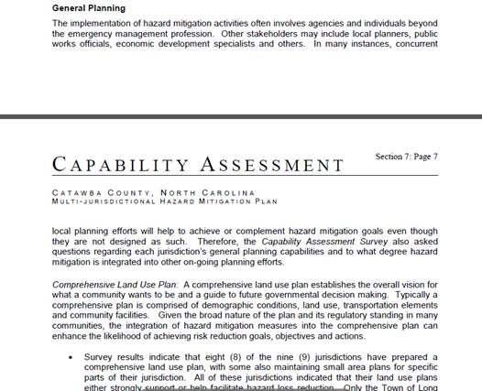

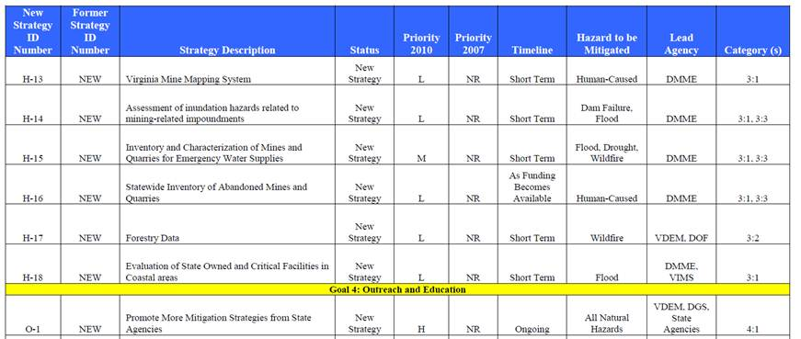

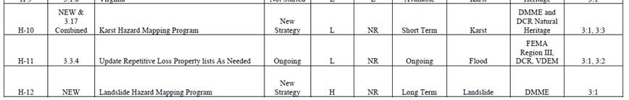

cid:image020.jpg@01CD2DE8.1054D4F0

**Items on agenda not discussed:**

## *Updates on Communication Efforts:*

1. **Article for Pipeline & Gas Journal**

**ACTION**: Susan – work is in progress. Jeff Share, Pipeline & Gas Journal, has offered to print article.

1. **P&G Journal Spring Conference 2013**

**ACTION:** Terri offered to contact them to see if a forum panel could get on the agenda. Possible topics related to PIPA to consider are encroachment programs and methods to identify new development along the pipeline ROW.

1. **API SmartBrief newsletter; AOPL newsletter**

**ACTION:** Terri Larsen will check into getting articles into those publications.

1. **Draft an email cover letter with attachment to stakeholder orgs. to distribute the evaluation tool.**

**ACTION:** Julie will draft cover letter for various stakeholder groups.

1. ***Draft Developer/Property Owner PIPA Evaluation Tool***

**ACTION:** Debbie asked Bruce Boncke and Chuck Lesniak offered to review the PIPA evaluation tool for land developers. Julie will provide a PIPA update to the Land Development Committee on June 8. They have offered to host a webinar to promote the tool after it is complete.

1. ***NACo PIPA webinar***

**ACTION:** James –webinar tentatively scheduled for June 28. May be moved to later date to include information about the hazard mitigation plan pilot. The webinar will be marketed to planners, emergency managers, county administrators, and maybe county attorneys. The webinar will include promotion of the evaluation tool for governments.

1. ***FAQs for website –*** have been posted
2. ***PIPA Planner Checklist*** – Julie has developed a Site Plan Review Checklist draft. ACTION: Distribute draft.
3. ***Draft the Agenda for PIPA Communication Team face-to-face meeting July 24-25*** 
   1. July 24 – Meeting with VDEM about hazard mitigation planning assistance guide for pipelines
   2. July 25
      1. Develop concept/design for revamping PIPA website
      2. Develop communication plan for next year
4. ***Open Discussion***

## Participants

| **Name** | **Organization Representing** | **Company** | **Email** |
| --- | --- | --- | --- |
| Cynthia Munyon* | NAPSR | Iowa Utilities Board | [cynthia.munyon@iub.iowa.gov](mailto:cynthia.munyon@iub.iowa.gov) |
| Steve Fischer | PHMSA | Pipeline and Hazardous Materials Safety Administration | [Steve.fischer@dot.gov](mailto:Steve.fischer@dot.gov) |
| Julie Halliday* | PHMSA | Pipeline and Hazardous Materials Safety Administration | [Julie.Halliday@dot.gov](mailto:Julie.Halliday@dot.gov) |
| Andrew Kohout | FERC | Federal Energy Regulatory Commission | [andrew.kohout@ferc.gov](mailto:andrew.kohout@ferc.gov) |
| Doug Sipes | FERC | Federal Energy Regulatory Commission | [doug.sipes@ferc.gov](mailto:doug.sipes@ferc.gov) |
| James Davenport | NACo | National Association of Counties | [jdavenport@naco.org](mailto:jdavenport@naco.org) |
| Jim Philipps | NACo | National Association of Counties | [jphilipps@naco.org](mailto:jphilipps@naco.org) |
| Chuck Lesniak | NLC | City of Austin, TX | [chuck.lesniak@austintexas.gov](mailto:chuck.lesniak@austintexas.gov) |
| Julia Pulidindi | NLC | National League of Cities | [pulidindi@nlc.org](mailto:pulidindi@nlc.org) |
| Debbie Bassert | NAHB | National Association of Home Builders | [dbassert@nahb.org](mailto:dbassert@nahb.org) |
| Erika Lee | CGA | Common Ground Alliance | [erikaa@commongroundalliance.com](mailto:erikaa@commongroundalliance.com) |
| Rebecca Craven | PST | Pipeline Safety Trust | [rebecca@pstrust.org](mailto:rebecca@pstrust.org) |
| Carl Weimer | PST | Pipeline Safety Trust | [carl@pstrust.org](mailto:carl@pstrust.org) |
| Gina Greenslate | API/AOPL | Panhandle Energy Companies | [gina.greenslate@sug.com](mailto:gina.greenslate@sug.com) |
| Terri Larson | API/AOPL | Enbridge Energy Company, Inc. | [terri.larson@enbridge.com](mailto:terri.larson@enbridge.com) |
| Greg Ford | INGAA | Williams | [Greg.r.ford@williams.com](mailto:Greg.r.ford@williams.com) |
| Andrea Grover | INGAA | Spectra Energy | [ADGrover@spectraenergy.com](mailto:ADGrover@spectraenergy.com) |
| Dwayne Teschendorf | INGAA | Spectra Energy | [DETeschendorf@spectraenergy.com](mailto:DETeschendorf@specgtraenergy.com) |
| Susan Waller | INGAA | Spectra Energy | [SDWaller@spectraenergy.com](mailto:SDWaller@spectraenergy.com) |
| Phil Bennett | AGA | American Gas Association | [pbennett@aga.org](mailto:pbennett@aga.org) |
| Chuck Kanoy | AGA | Vectren | [bckanoy@vectren.com](mailto:bckanoy@vectren.com) |
| Lydia Meigs | AGA | American Gas Association | [lmeigs@aga.org](mailto:Lmeigs@aga.org) |
| Matthew Wall | VDEM | Virginia Department of Emergency Management | [Matthew.Wall@vdem.virginia.gov](mailto:Matthew.Wall@vdem.virginia.gov) |
| Herb Wilhite | Cycla | Cycla Corporation | [herbw@cycla.com](mailto:herbw@cycla.com) |
| * Co-Leaders |  |  |  |